A report on

**Quiz Web Application**

Submitted by

**AMIT KUMAR : 20BCS028**

**CHANDRAVANSHI SHUBHAM ARUN : 20BCS064**

**SUMIT YADAV : 20BCS222**

**CSE, 2020**

Submitted to

**Prof. Pritee Khanna**



PDPM INDIAN INSTITUTE OF INFORMATION TECHNOLOGY, DESIGN AND

MANUFACTURING JABALPUR, INDIA

November 16th , 2021

1. Introduction
2. Purpose & Scope
3. Users
4. Overall Description
   1. System Features and Requirements
   2. Functional Requirements
   3. External Interface Requirements
   4. Non-functional Requirements
5. Technology Used
6. Database Designing
   1. Entity Relationship Diagram (ERD)
7. Project Screenshots

**Introduction**

This is an Online Web Quiz Portal, A platform for conducting online Quiz exam or Practice Mock Test where multiple users can login and give all exam at most once and get the instant final result

This application has two level of Users

1) Teacher who can conduct any Quiz

2) Students who can give the Available Quiz

This application will help the Teachers to conduct a multiple Quiz or a practice Mock Test or Contest with good user-friendly interface in creating questions and it’s option and will have the additional feature of changing the answer and re-evaluating the marks for all students.

This application will help the students to undertake all the quizzes and participate in them and get the instant result of the quiz and get the detail of each question like which question student had attempted correctly and which were attempted incorrect and which were not attempted with the correct answer given by the administrator.

**Purpose & Scope**

The main objective of this project is to make eaze to conduct Quiz online and thus push forward the idea of paperless Examination.

This application will also help the students to keep all the records of the quiz he has given with the detail of questions which he has not attempted or marked incorrect so that students in future can go through these questions and improve his concepts.

This application will help the Teachers in creating the question and option and the application will automatically evaluate marks of each student and also in future if there is change in any grading Teacher can easily change the answer of questions and re-evaluate the quiz with just one click.

This application will surely help the students in the preparation of their any kind of exams and help them to achieve their goals.

**User**

There will be mainly 2 type of Users in this application

1. Student
2. Teacher

**a) Student**

The student can give all the available quiz once and get the instant score and can see their result and and can easily and can also see the answer of the questions after completing the quiz and can also see what they attempted

**b) Teacher**

Teacher can create the quiz and question which will be visible to all the students and teacher can also edit,update and remove the quiz and question and can also re-evaluate the quiz

There will also be one administrator who can see all the teachers and student created account in our quiz application and if by any mean it is necessary he can also remove their account from this application

**Module/Features**

* **Login**

User will authenticate enter username and password

* **User**

User will enter his name and take the role and will get a unique Role ID which will be used further as a key attribute.

1. **Teacher**

Teacher will be having a home page page and about page and Teacher will get the power of creating,editing,removing any Quiz and Question and it’s corresponding options and also make changes in the evaluation Schema or the in the question and can very easily re-evaluate the quiz

1. **Student**

Student will also have a home page page and about page and can give all the Quiz which are create at most once and will get the instant result and can preview his attempt with its corresponding correct answers

* **Quiz**

The teacher can create a Quiz and give the Quiz name , Quiz description. Which can also be edited and removed later if required

* **Questions and Option**

The teacher will create the question and It’s corresponding option and mark which option is correct in answer attribute and when student will mark the option the option_ID will be store in the Attempt_ID and in server side we will be check whether the option is correct or not using SQL query

**Database**

Login info:

It will have the user's Username as a primary key and Password.

User info:

It will have to User’s full name , Role user had selected and Role ID as a primary key and Username as foreign key

Quiz make info:

It has t Role_ID , Quiz_ID which tell which user had created which quiz.

Quiz info:

It has the Quiz_ID, Quiz name, Quiz description, where Quiz_ID will be our primary key

Que info:

It has the Quiz_ID Que_ID, Que description, where Que_ID will be our primary key and Quiz_ID will be our foreign key

Option info:

It has the Que_ID, Option_ID, Option description, where Option_ID will be our primary key and Que_ID will be our foreign key

Give info:

It consists of the Quiz_ID of a quiz given by the student which will be our foregin key and will have the Role_ID of the student as a foregin key and will also have the corresponding marks student got in that quiz with it’s total marks.

Question_attempt info:

It consist of the Role_id, Quiz_ID,Question_ID which will be our foreign key and the attempt_ID all this will tell the which student have attempted which option of which question in which quiz and will also have to attempt detail which tell if the option selected was right or wrong

**External Interface requirements**

User Interface: The software provides a good graphical interface for the user and an administrator can operate on the system, performing the required tasks.

**Hardware requirements**

Operating system : Any (windows, mac or linux)

Hard disk :40 GB

RAM : 2 GB(min)

Processor : Pentium(R)Dual-core CPU4.(min.)

Software Interface: XAMPP, A web browser.

Communication Interface: As this is a web based application, the communication between the user can be done from any web browser.

**Technology Used**

As this application is a web-based application so we have used web technologies like:

**Frontend:**

a. HTML5

b. CSS4, SCSS

c. Bootstrap5

d. ES6(JavaScript)

e. ReactJS

**Backend:**

a. JavaScript

b. Node.js

c. Express.js

d. MySQL

**Hosting:**

a. Heroku

b. phpMyAdmin.co

**ER MODEL**

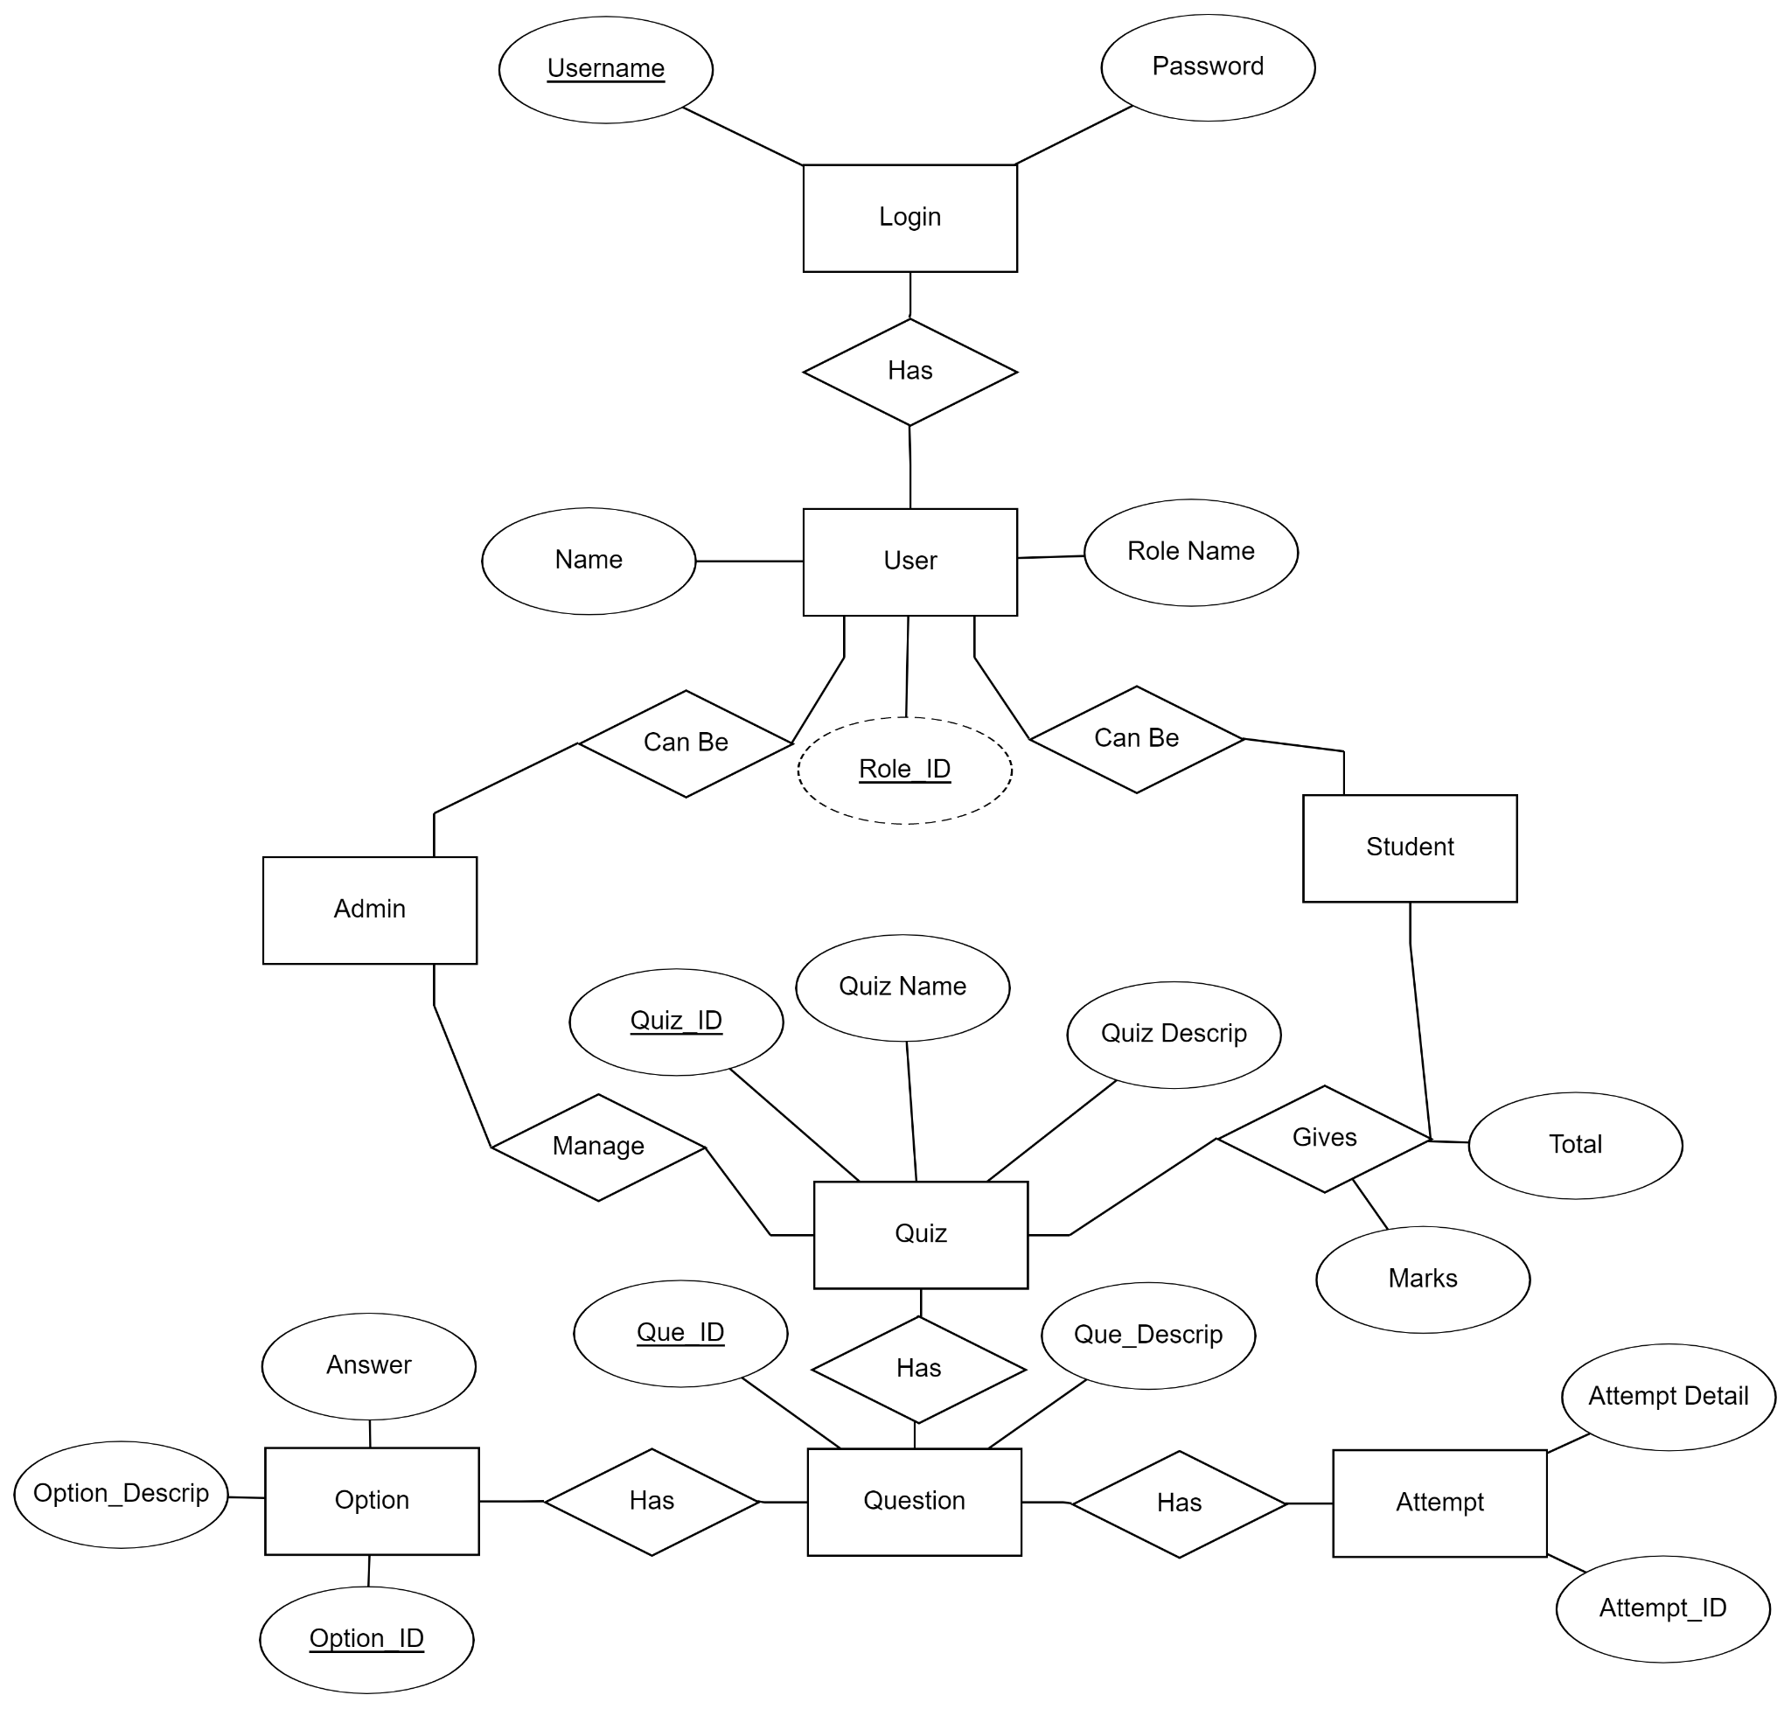

**Relational Table**

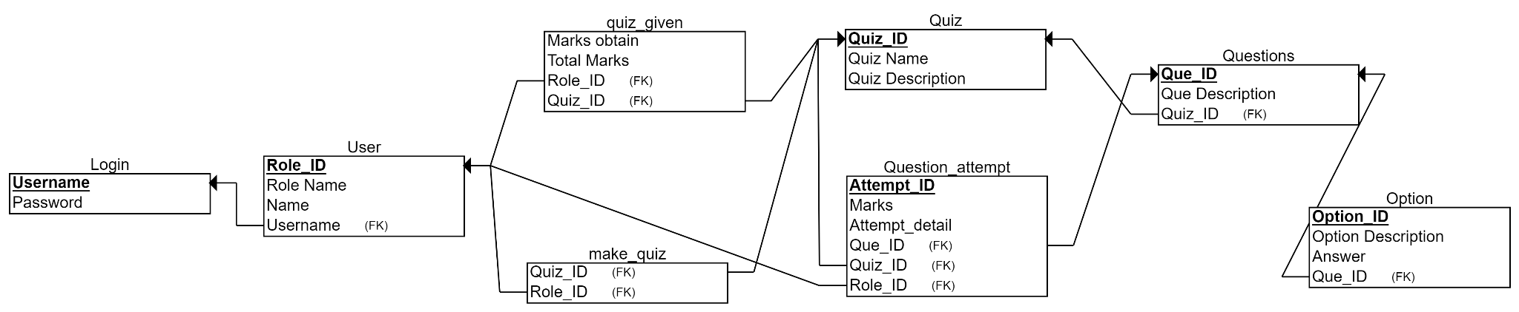

**Some Screenshot from Project**

